Open Source Intensity Interferometer
Ilia Platone

E-mail: info@iliaplatone.com
Abstract
Radio telescopes observe the part of the electromagnetic spectrum comprised from the millimeter range until kilometer range wavelength, for this reason the diameter of the telescopes need wide apertures to increase the maximum obtainable resolution. To increase the instrument resolutivity, although the light collecting capacity is limited to the single dish area, interferometers are used.
Optical detectors, and subsequently radio receivers or detectors, need a system to cross-correlate their readouts in interferometer configurations rather than single detector or radio dish. These devices are common in wide number associations, astronomers clubs, professional observatories and universities. The amateur astronomers community keeps the need to have relationships with these realms to find a way to observe the sky in high angular resolution in both the radio and visible spectrum.
The work I describe here is a cross-correlator for geiger mode TTL-level sensors that aims to be cost-effective, simple in its kind, expandable and a software that permits to obtain images at higher resolution in the range of wavelengths that are comprised between the radio and ultra-violet spectrum.

1. The correlator structure
The structure makes use of most used Linux software dedicated to astronomy: Instrument Neutral Distributed Interface (INDI) library and its protocol, capable of communication and interfeasibility with web interfaces and web back/front ends and programming languages, the DSP part of INDI is used here for Fourier plane transformations and imaging, spectra and histogram analysis, the libRTK library is used for precise differential positioning of the telescopes, and the INDI library snooping feature to link properies of mountings and GPSes of each telescope with the correlator driver. The structure has a hardware part composed by an FPGA cross-correlator with a 12 channel input capacity with ns scale resolution and clock.
1.1 The hardware
The hardware used in this project is a Lattice MachXO3 FPGA, that is programmed with an open-source, GPL3-licensed Verilog code that permits line cross-correlation, flagging and compile-time configuration of the interferometer. Motor controllers will be used in real sky enviromnent tests and will drive customized mountings, logically driven by INDI, will communicate with the interferometer driver application so to report their current celestial coordinates targeting position.
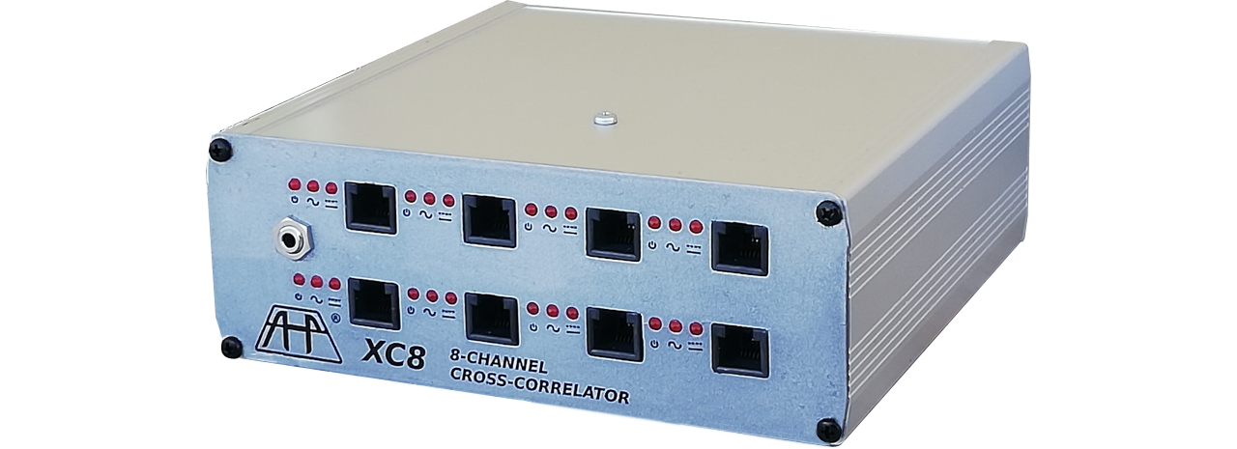Figure 1: The XC8 correlator
Three types of detectors are used each test run, two optical detectors and a radio amplifier and pulse convertor:
- Type FEU-17A (USSR photomultiplier tube, visible spectrum with peak in 350-400nm)
- Type FEU-39A (USSR photomultiplier tube, U spectrum, 380-420nm)
- Radio amplifier and pulse converter, wide bandwith, to be used with externally tuned antennas.
Each detector line is connected to the correlator FPGA with an 8-way connector hub, line enabling and powering is done using the flag lines of the FPGA software.
1.2 The software
The software used is an INDI driver application and has these features:
- Belongs to the CCD interface class.
- Dynamic line allocation.
- Snoops each line’s telescope target coordinates from a connected telescope.
- Snoops each line’s GPS location from each telescope GPS.
- Calculates each line delay in meters.
- Common integration control of all lines.
- Reports each line readout in pulse quantity at the timeout rate.
- Reports the correlations number of each node with others.
- Reports the coherence ratio of each node with others.
- Fills the Fourier plane with the coherence ratio readout during the integration.
- Finds correct Fourier plane location using aperture synthesis perspective.
- Selects common observed wavelength.
- Calculates and sets the delay path length of each line
2. Laboratory tests
2.1 Power lines and first readouts
The first tests, after assembling the correlator and the PMT into its housing, were made by checking the safety issues and actual working status of the correlator firtsly, and the PMT socket/voltage supply. The PMT is soldered into the socket board, which includes both power supply voltage multiplier and the reading amplifier/discriminator. The voltage multiplier is supposed to multiply a 115VAC voltage into 1500VDC rectified supply, reduced then to the nominal PMT voltage of 1400V. The readout discriminator is composed by a high pass filter with a cutoff at 100ns, and a RF wideband BJT amplifier, all throught-hole components for easy soldering and reprodcution.
The FPGA has an internal delay line memory for each node and this feature can be used as internal phase alignment for astronomical aperture synthesis observations.
Each baseline has a ranged jitter cross-correlator for the comparison of time-tagged pulses.
The Verilog code also can be adapted for usage on different chips of various LUT capacity, so different memory sized FPGAs can be used for greater jitter lines or delay lines.
Each line has two power lines connected to the led flag lines of the FPGA, one supplies the PMT board with the BJT TTL voltage, the second one switches on a relay to supply 115VAC for the multiplication.
The Correlator is connected to the PMT with an RJ12 connector, and since the 115VAC voltage is thrown by the correlator, the high voltage part is restricted to the PMT socket board only.
2.2 Software tests
The software is then being tested and updated until this article redaction. The INDI library is an open-source library and package collection that is actively developed and updated. Adding a driver for this correlator into INDI was the best choice since the open-source and free-software nature of the latter permits corrections and better distribution of results and opinions.
INDI works as a library and every application linked with the core, even the server, talks to others using its protocol, an XML-like socket that sends updates, commands and data from one device to others or the client connected to it.
The correlator subject of this article inherits the CCD class of INDI, that is used by many applications ot the software library of INDI.
The correlator application plots the observation integrations by filling a Foourier plane with the coherence degrees of each baseline, plotting is thought to be done for astronomical observations, so aperture synthesis algorithms were integrated into INDI in past for this purpose.
The integration plot is then shown by the driver like a CCD image.
Since the aperture synthesis needs long integrations for a sufficient plane filling, integration times are much longer than a common CCD camera, for this reason the correlator application is much different from a classical CCD and must not be confused with it.
The driver also shows an estimation of a 0 magnitude star photon flux for comparison with the readout of the current line photon flux.
Also correlation numbers and coherence ratios information tab is present where each baseline can be compared with others each time, for debug and informational purposes.
At the moment of this article redaction the software is fully functional for test purposes and initial usage.
The user can also setup a different wavelenght and filter bandwitdth. This feature widens the detector range to radio dishes or receivers and X/Gamma ray detectors.
2.3 Dark count measurement
After assembling the PMT into its housing, detection tests of the photon flux obtained with low environmental light illumination and the PMT housing closed were done. Around 7x10³ pulses/s were measured, yelding a photon flux of 1.98x10⁻¹² Lumen, and the estimated photon flux at magnitude 0 with a 1m F/5 mirror was estimated to 6.38x10⁻¹¹ Lumen, the resultant magnitude of the dark noise was 3.77. This led us to assume that limiting magnitudes are of the brightest stars even with large light buckets.
Future perspectives
This project, althought is potentially demanded to private builders or assemblers for the hardware part, is aimed for a large number of users, and a possible situation would be an inter-institutional collaboration between technical institutes and scientifical or aempyrical addressed schools for cross-collaboration.
The initial goal for the correlator usage was to furnish small observatories of an instrument like this. This goal would be enforced by the open source nature of the same.
Cross-correlation of readings from Geiger Mueller tubes can give informations about cosmic rays like Muons. Small Gamma-Ray Cherenkov arrays could be built using this correlator as processing core.
Laboratory experiments in secondary schools can be done using cosmic-ray detectors with photomultiplier tubes and directly processed with custom software.
Since the FPGA communicates with the host using UART ASCII messages, it is possible to quickly interface it with custom software.
This correlator can also be useful in multi-messenging observations, like neutrin emission detection during fast Gamma Ray Bursts (GRBs) events generated by black-hole collisions, Active Galaxy Nucleus or supernovae explosions.
Conclusion
Since the photometer has a small efficiency at higer magnitudes, this should be used with light buckets with large collecting areas.
The greatest advantage of this module is that the sensible area of the PMT Is larger than APD or CCD sensors. Even APD arrays are smaller in size and detection area. The mirror’s accuracy of the light buckets is allowed to be lower than standard optical-grade telescope mirrors. An economic flat mirrors composed light collector and a secondary higher-end concentrator should be sufficient for efficient light collection even with small efforts.
The low bandwidth of the correlator also permits greater error margin in telescopes locations and delay lines.
This instrument is an economic and crowd-sourced way to obtain high resolution observations, and the module interchangeability wides the range of detectors to more devices. The correlator can be connected to PMTs, GMTs, pulse detectors and can drive other kinds of devices with pulsing output, the relay line is directly connected to a common source that can be changed upon the needs.

